KPI’s:

Total loan applications

SELECT COUNT(id) AS Total_Loan_Applications FROM Bank_Loan_Data



SELECT COUNT(id) AS MTD_Total_Loan_Applications FROM Bank_Loan_Data

WHERE MONTH(issue_date) = 12 AND YEAR(issue_date) = 2021



SELECT COUNT(id) AS PMTD_Total_Loan_Applications FROM Bank_Loan_Data

WHERE MONTH(issue_date) = 11 AND YEAR(issue_date) = 2021



SELECT SUM(loan_amount) AS Total_Funded_Amount FROM Bank_Loan_Data



SELECT SUM(loan_amount) AS MTD_Total_Funded_Amount FROM Bank_Loan_Data

WHERE MONTH(issue_date) = 12 AND YEAR(issue_date) = 2021



SELECT SUM(loan_amount) AS PMTD_Total_Funded_Amount FROM Bank_Loan_Data

WHERE MONTH(issue_date) = 11 AND YEAR(issue_date) = 2021



SELECT SUM(total_payment) AS Total_Amount_Received FROM Bank_Loan_Data



SELECT SUM(total_payment) AS MTD_Total_Amount_Received FROM Bank_Loan_Data

WHERE MONTH(issue_date) = 12 AND YEAR(issue_date) = 2021



SELECT SUM(total_payment) AS PMTD_Total_Amount_Received FROM Bank_Loan_Data

WHERE MONTH(issue_date) = 11 AND YEAR(issue_date) = 2021



SELECT ROUND(AVG(int_rate)*100,2) AS Average_Interest_Rate FROM Bank_Loan_Data



SELECT ROUND(AVG(int_rate)*100,2) AS MTD_Average_Interest_Rate FROM Bank_Loan_Data

WHERE MONTH(issue_date) = 12 AND YEAR(issue_date) = 2021



SELECT ROUND(AVG(int_rate)*100,2) AS PMTD_Average_Interest_Rate FROM Bank_Loan_Data

WHERE MONTH(issue_date) = 11 AND YEAR(issue_date) = 2021



SELECT ROUND(AVG(dti)*100,2) AS Average_DTI FROM Bank_Loan_Data



SELECT ROUND(AVG(dti)*100,2) AS MTD_Average_DTI FROM Bank_Loan_Data

WHERE MONTH(issue_date) = 12 AND YEAR(issue_date) = 2021



SELECT ROUND(AVG(dti)*100,2) AS PMTD_Average_DTI FROM Bank_Loan_Data

WHERE MONTH(issue_date) = 11 AND YEAR(issue_date) = 2021



SELECT

(COUNT (CASE WHEN loan_status = 'Fully Paid' OR loan_status = 'Current' THEN id END)*100)

/

COUNT(id) AS Good_Loan_Percentage

FROM Bank_Loan_Data



SELECT COUNT(id) AS Good_Loan_Applications FROM Bank_Loan_Data

WHERE loan_status = 'Fully Paid' OR loan_status = 'Current'



SELECT SUM(loan_amount) AS Good_Loan_Funded_Amount FROM Bank_Loan_Data

WHERE loan_status = 'Fully Paid' OR loan_status = 'Current'



SELECT SUM(total_payment) AS Good_Loan_Received_Amount FROM Bank_Loan_Data

WHERE loan_status = 'Fully Paid' OR loan_status = 'Current'



SELECT

(COUNT (CASE WHEN loan_status = 'Charged Off' THEN id END)*100)

/

COUNT(id) AS Bad_Loan_Percentage

FROM Bank_Loan_Data



SELECT COUNT(id) AS Bad_Loan_Applications FROM Bank_Loan_Data

WHERE loan_status = 'Charged Off'



SELECT SUM(loan_amount) AS Bad_Loan_Funded_Amount FROM Bank_Loan_Data

WHERE loan_status = 'Charged Off'



SELECT SUM(total_payment) AS Bad_Loan_Received_Amount FROM Bank_Loan_Data

WHERE loan_status = 'Charged Off'



SELECT

loan_status,

Count(id) AS Total_Loan_Applications,

SUM(total_payment) AS Total_Amount_Received,

SUM(loan_amount) AS Total_Funded_Amount,

AVG(int_rate)*100 AS Interest_Rate,

AVG(dti)*100 as DTI

FROM

Bank_Loan_Data

GROUP BY

loan_status

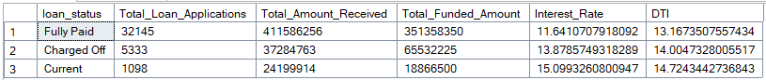

SELECT

loan_status,

SUM(total_payment) AS MTD_Total_Amount_Received,

SUM(loan_amount) AS MTD_Total_Funded_Amount

FROM

Bank_Loan_Data

WHERE

MONTH(issue_date) = 12

GROUP BY

loan_status

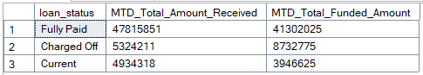

SELECT

MONTH(issue_date) AS Month_Number,

DATENAME(MONTH, issue_date) AS Month_Name,

COUNT(id) AS Total_Loan_Applications,

SUM(loan_amount) AS Total_Funded_Amount,

SUM(total_payment) AS Total_Amount_Received

FROM

Bank_Loan_Data

GROUP BY

MONTH(issue_date),DATENAME(MONTH, issue_date)

ORDER BY

MONTH(issue_date)

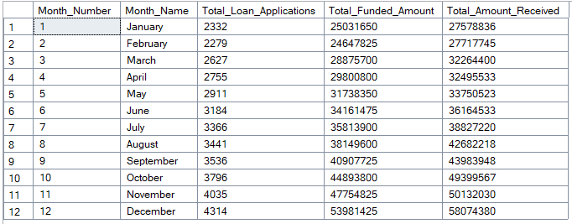

SELECT

address_state,

COUNT(id) AS Total_Loan_Applications,

SUM(loan_amount) AS Total_Funded_Amount,

SUM(total_payment) AS Total_Amount_Received

FROM

Bank_Loan_Data

GROUP BY

address_state

ORDER BY

SUM(loan_amount) DESC

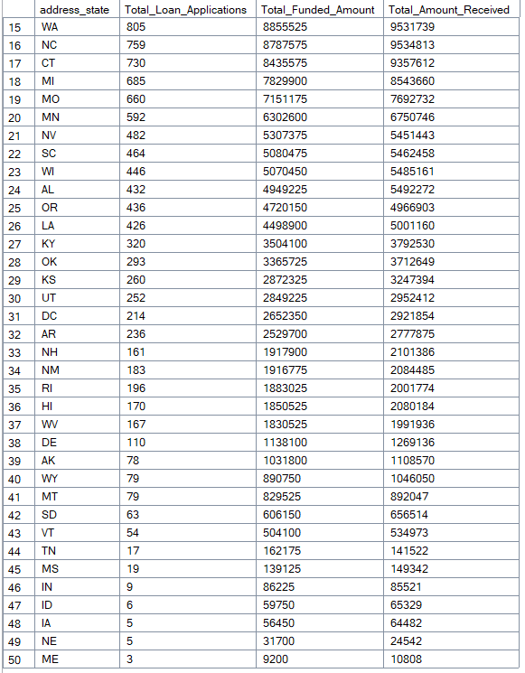

SELECT

term,

COUNT(id) AS Total_Loan_Applications,

SUM(loan_amount) AS Total_Funded_Amount,

SUM(total_payment) AS Total_Amount_Received

FROM

Bank_Loan_Data

GROUP BY

term

ORDER BY

Term

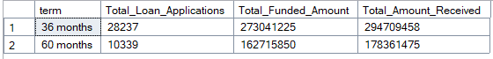

SELECT

emp_length,

COUNT(id) AS Total_Loan_Applications,

SUM(loan_amount) AS Total_Funded_Amount,

SUM(total_payment) AS Total_Amount_Received

FROM

Bank_Loan_Data

GROUP BY

emp_length

ORDER BY

emp_length

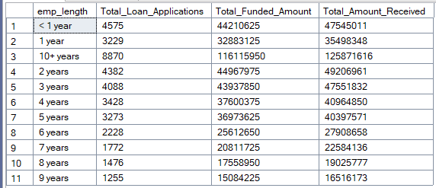

SELECT

purpose,

COUNT(id) AS Total_Loan_Applications,

SUM(loan_amount) AS Total_Funded_Amount,

SUM(total_payment) AS Total_Amount_Received

FROM

Bank_Loan_Data

GROUP BY

purpose

ORDER BY

COUNT(id) DESC

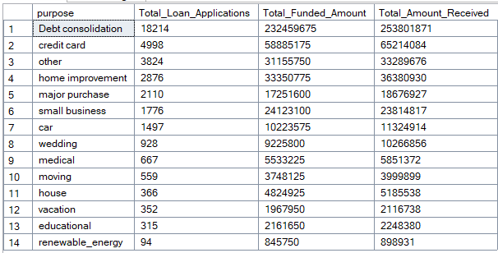

SELECT

home_ownership,

COUNT(id) AS Total_Loan_Applications,

SUM(loan_amount) AS Total_Funded_Amount,

SUM(total_payment) AS Total_Amount_Received

FROM

Bank_Loan_Data

GROUP BY

home_ownership

ORDER BY

COUNT(id) DESC

